Field legume response to inoculation with Rhizobium in the Sud Kivu province, DR Congo
MASAMBA J. WALANGULULU ¹, TOROMA E. SIKA¹, NTABOBA L. CIZUNGU¹, Wa LOLA J. MULUMUNA¹ and F. BAIJUKYA ²

1: Université Catholique de Bukavu (U.C.B.), B.P. 2 Cyangugu, Rwanda
2 : CIAT-TSBF, P.O. Box 30677-00100, Nairobi, Kenya. Corresponding author: Prof. Walangululu e-mail: walangululu@yahoo.fr
Abstract
The success of nitrogen biological fixation by legumes in the field depending on the interaction legume genotype x Rhizobium strain x environment x management, the objective of this work was to test the inoculation response of five varieties of common beans and soybean to commercial rhizobium strains on a degraded and fertile soil in Ikoma and Bugorhe local areas of Sud Kivu province, Democratic Republic of Congo.
Trial was carried out in a split plot design in three replications, with inoculation and varieties as factors. P and K, limiting factors for nitrogen fixation, were applied on all plots. Observations were made on percentage germination, plant height at 50 % podding, pests and diseases, soil covering rate and yield.

Results revealed that referring to yield, bean response to inoculation was low and differed between sites, while soybean response to inoculation is greater and also varies between places. Nitrogen supplementation showed that fertile soil contained sufficient nitrogen, whereas other factors interfered in nitrogen fixation in degraded soils; there was no difference in bean yield between nitrogen supplemented soils and no nitrogen supplemented soils. As for soybean, yield was higher in nitrogen supplemented soils in the two locations.

These results also provided guidance on the design of soybean need-to-inoculate trials which are now ongoing.

Key words: soybean, common bean, DRC, inoculation, yield

Résumé

Le succès de la fixation biologique d’azote par les légumineuses étant tributaire de l’interaction génotype légumineuse x souche de Rhizobium x conditions d’environnement x gestion de bonnes pratiques, il a été entrepris dans le cadre du projet N2Africa des essais dont l’objectif était de tester la réponse de cinq variétés de haricot et de soja à l’inoculation en utilisant des souches commerciales sur un sol dégradé du groupement d’Ikoma en territoire de Walungu, en comparaison avec un sol fertile du groupement de Bugorhe, en territoire de Kabare, en province du Kivu, République Démocratique du Congo.

Les essais ont été conduits sur un dispositif de parcelles subdivisées en trois répétitions, avec comme facteur principal l’inoculation, à deux niveaux, et comme facteur secondaire les variétés, à cinq niveaux. Afin de minimiser l’influence des facteurs limitants, du phosphore et du potassium ont été uniformément appliqués dans toutes les parcelles. Dans chaque répétition, une parcelle a été ajoutée, sur laquelle on a appliqué l’urée, pour déceler la présence ou l’absence d’azote initial dans le sol.

Les observations ont porté sur le pourcentage de germination, la hauteur des plants à 50 % de nouaison, le taux de recouvrement du sol et le rendement.

Les résultats ont montré que considérant le rendement, la réponse du haricot à l’inoculation a été très faible, quel que soit le type de sol et quel que soit le site mais varie d’un site à un autre. La réponse du soja, au contraire, a été très nette mais varie d’un site à un autre et en fonction du type de sol et des variétés. L’influence de la dose de P n’a pas été remarquée, selon les types de sol. L’ajout d’urée a montré que dans le sol dit fertile, il y avait suffisamment d’azote au départ et le rendement des parcelles avec ajout de l’urée était plus élevé ; mais dans le sol dit pauvre, des facteurs limitants ont sûrement empêché l’expression de l’azote fournie sous forme d’urée mais le rendement était plus élevé que dans les parcelles où on n’a pas mis l’urée.

Ces essais ont ainsi donné lieu à d’autres essais d’inoculation du soja à travers tous les sites d’action du projet N2Africa ; les résultats de ceux-ci apparaîtront ultérieurement.

Mots clés : soja, haricot, DRC, inoculation, rendement.
Introduction
N2Africa, a CIAT-TSBF project, was launched in Nairobi, during a meeting held from 18 to 22 January 2010 and is working in 8 African countries, among them the Eastern part of DR Congo, in the Sud Kivu province. His aim is putting nitrogen biological fixation to work for smallholder African farmers. N2Africa is a new initiative proposed, in which legumes are used as a basis for improving cropping systems and household well-being, increasing inputs from biological nitrogen fixation (BNF) that will link family protein supply and farm nitrogen inputs directly to the atmosphere, will improve soil health and will increase household incomes. Technology used in the project has been used for decades by farmers in the North America and Brazil, but according to Sanginga (quoted by Giller, 2010), African farmers have been denied access to these methods for far too long.
Agricultural production in most parts of sub-Saharan Africa is dominated by smallholder farming systems of low productivity, resulting in the per capita low production of agriculture products. Intensification of low-input agricultural production has led to a rapid increase in soil degradation and nutrient depletion in many parts of sub-saharan Africa, constituting serious threats to food production and food security (Giller, 2010). As stated by Norman Borlaug in 2003 during a speech in U.S.A. “the soil nutrient losses in sub-Saharan Africa are an environmental, social and political time bomb. Unless we wake up soon and reverse these disastrous trends, the future viability of African food systems will indeed be imperiled”. Better managing soil fertility is therefore an imperative for sub-Saharan Africa.
Nitrogen is the nutrient element most limiting to plant growth. Sanchez (1997) stated that nitrogen deficiency results from its continual depletion from the soil pool by processes such as volatilization, leaching and, perhaps most importantly, removal of nitrogen-containing harvest products and crop residues from the land. Therefore replacement of fertility should be considered as an investment in natural resources capital.
Two ways are indicated for soil nitrogen replacement: chemical fertilizer use and nitrogen biology fixation by capturing nitrogen from the air and make it available to crops in the form of natural fertilizer. Chemical fertilizer is the fuel that has powered the green revolution’s forward thrust, according to Norman Borlaug. Fertilizer mostly improves crop yields but it also increases the quantity of available crop residues useful as livestock feed or organic input to the soil (Bationo et al., quoted by Sanginga and Woomer, 2009). For Sanginga and Woomer (2009), the incorporation of legumes into cropping systems provides additional benefits besides N input, particularly in terms of pest and disease control. Larger integration of nitrogen-fixing legumes into cropping systems is part of ISFM features with particular relevance in Africa small-scale farming systems.

The BNF process is mediated much more efficiently by bacteria; plants benefit from this process when the bacteria (called collectively Rhizobia in leguminous crops) die and release the nitrogen to the soil or when the bacteria live in very close association with plants. In Brazil, rates of nitrogen fixation with soybeans under field conditions can exceed 300 kg of N ha⁻¹ each year, providing up to 94 % of total plant N and an estimated saving to the economy of up to US$ 6.6 billion per year (Hungria et al., quoted by Giller, 2010). This can, if applied in Africa, meet the goal of Abuja Summit held in 2006 in Abuja, Nigeria, where African heads of states decided a fertilizer use intensity of 50 kg nutrients ha⁻¹ by African farmers.
The success of nitrogen biological fixation by legumes in the field depends on the interaction (LxR) x E x M (legume genotype x Rhizobium strain x environment x management), where environment encompasses climate (temperature, rainfall, day length, etc. to encompass length of growing season) and soils (acidity, aluminum toxicity, limiting nutrients, etc.). Management includes aspects of agronomic management (use of mineral fertilizers, sowing dates, plant density, weeding).
Legume hosts differ in the range of partners with which they form symbioses. At one end of the spectrum are legumes which nodulate with a restricted number of rhizobial strains or species and are thus considered as specific in their rhizobia requirement; at the other end other legumes are considered as the most promiscuous (or non specific) of the grain legumes, nodulating with a range of both fast and slow-growing rhizobia (Giller, 2010). As for environment, Sud Kivu province presents a large scale of soil types, ranging from fertile volcanic soils to degraded kaolinic soils.
The global market for rhizobial inoculants is dominated by soybean, due to its strong requirement for inoculation. Thus, the objective of this work was to test the inoculation response of five varieties of common bush beans and soybean to commercial rhizobium strain in a called degraded soil, Walungu administrative areas, compared to a called fertile soil in Kabare action sites of N2Africa project.

Material and methods
This work was carried out in farmer fields in two villages of Ikoma local area (Kahemb ari for bush beans and Karhongo for soybean), Kabare administrative area and Bugorhe local area for bush beans and soybean, Walungu administrative area. In Walungu administrative area soils are known as degraded whereas in Kabare administrative area, they are less degraded (Pypers, 2010).
The experimental design was a split plot design in three replications, with inoculation and no inoculation as the main factor, and five varieties as the second factor. Varieties used were CODMLB001, AFR 708, Marungi, RWR 10 and More 8802 for beans and PK 6, 449/16/6, Imperial, SB19 and SB 24 for soybean; they were obtained from Ciat-BNF, Nairobi, and multiplied by INERA Mulungu. In each replication one plot was added, where urea, at a rate of 30 kg ha⁻¹ was applied to assess the initial deficiency of N in the soil. P, as TSP and K, as KCl, limiting factors for BNF, were applied at a rate of 30 kg ha⁻¹ on all plots at the sowing date. Plots were of 3 x 2.5 m.
Beans and soybean were sown at a spacing of 40 x 10 cm. Observations were made on percentage germination, plant height at 50 % podding, pests and diseases, soil covering rate and yield.
Results and discussion
- Bean and soybean yield under urea and no urea application.
Results on the yield of bean and soybean under urea and no urea application are given in figures 1 for bean and 2 for soybean.
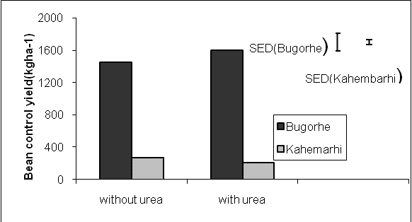
Fig.1. Bean yield under urea and no urea application
Results from fig. 1 have shown that bean did not respond to urea application, either in fertile or no fertile soil, no difference appeared in each type with or without urea application; yield was higher in fertile soil than on degraded soil. This is in line with literature that response of bean is very poor where there is enough nitrogen or lack of nitrogen. Although nitrogen was supplemented, no response mainly in degraded soil can be explained by the fact that nitrogen is not the only the limiting factor in the soil; the pH, which is below 5 in this case of degraded soil, can limit the legume growth.
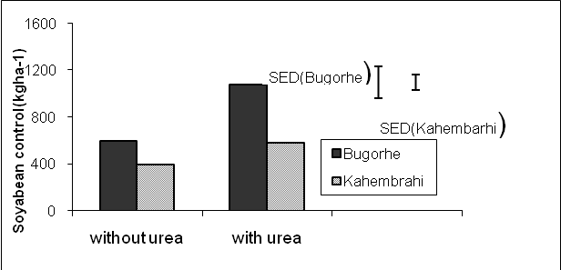
Fig. 2: Soybean yield under urea and no urea application
Response of soybean under urea application is clearly higher than that of no urea application and in both sites urea application gave higher yield than in no urea application. The difference in yield between urea application and no urea application suggested that inoculation of soybean can still be of effect in both sites and soil types.
- Bean and soybean height plant under inoculation and no inoculation

Results of bean height plant under inoculation and no inoculation are shown in figures 3 and 4 for Bughore and Kahembari and those for soybean in figures 5 a nd 6.
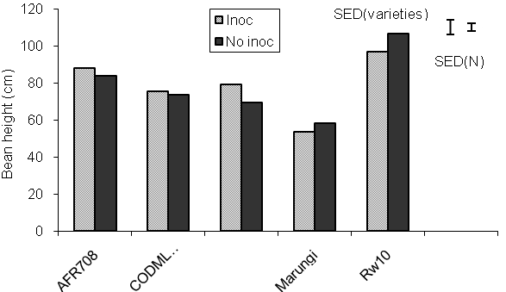
Fig. 3: Bean height at Bugorhe
Results on bean height at Bugore (fertile soil) showed differences between inoculation and no inoculation plants for AFR 708, More 8802, Marungi and Rw 10, and no difference for CODMLB001, suggesting variety differences in response to inoculation. Comparing varieties, inoculated and no inoculated plants of Rw 10 variety showed higher plant height whereas lower plant height was recorded on Marungi variety, suggesting genetic differences of varieties. Results on bean height at Kahembari (degraded soil) showed differences between inoculated and no inoculated plants on all varieties, except on More 8802; as for differences among varieties, the higher value recorded on inoculated AFR 708, followed by inoculated Rw 10 and Marungi; inoculated More 8802 and CODMLB001 were equivalent. These results suggested also variable legume response.
Comparing bean plant height in Kahembari to that of Bugorhe, one could find that this was higher on fertile soil of Bughore.

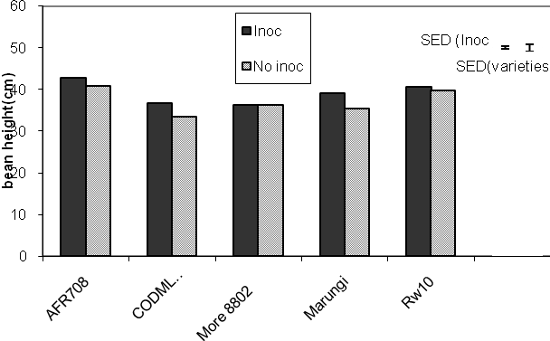
Fig. 4: bean height at Kahembari
Soybean plant height of inoculated plants at Kahembari was higher than that of no inoculated plants for all varieties, except for SB 24 and 449/16/6 varieties; no inoculated plants of SB 24 showed higher plant height than inoculated of the same variety; the higher value was recorded on 449/16/6, followed by SB 19, SB 24 and PK 6, the lowest value recorded on Imperial, suggesting that 449/16/6 was the most responsive on that soil type.
At Bughore, differences between inoculated and no inoculated plants appeared only on 449/16/6 and Imperial varieties, whereas there was no differences on other varieties. Plant height on this type of soil was higher than at Kahembari.
Plant height is recorded at 50 % podding when the growth has almost ended; it is the time when N fixation is at the mean level, suggesting that N fixation is not reflected through plant height.
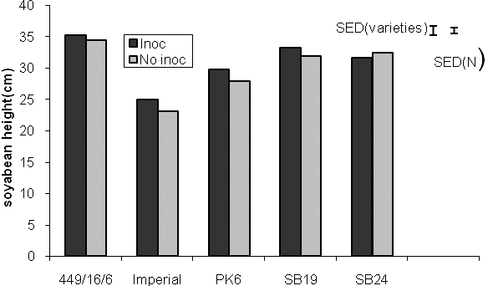
Fig. 5: soybean height at Kahembari
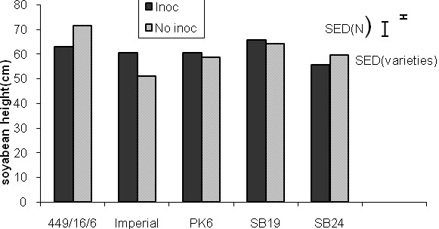
Fig. 6: soybean height at Bugorhe

- Bean and soybean land cover rate under inoculation and no inoculation
Bean land cover rate under inoculation and no inoculation is illustrated in figure 7 at Kahembari and figure 8 at Bugorhe. Fig 7 showed no land cover differences between inoculated and no inoculated plants, varying from 58 to 64 %; this could explain that the time of efficient nitrogen fixation occurs when growth has ended.
Fig 8 showed that land cover rate at Bugorhe was high (100 % for almost all varieties) and was not different from inoculated and no inoculated plants, except for More 8802 and Rw 10 bean varieties, where land cover rate of no inoculated plants was higher and statistically different than those of inoculated plants.
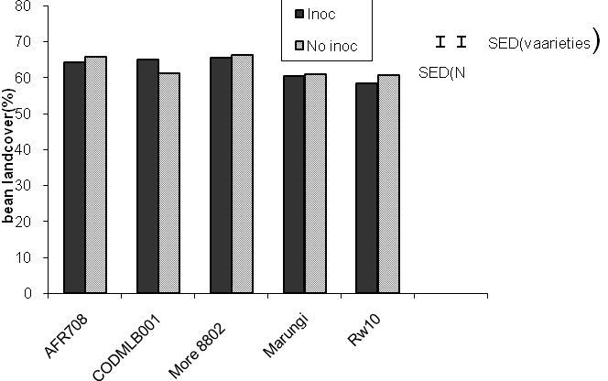
Fig. 7: bean land cover rate at Kahembari

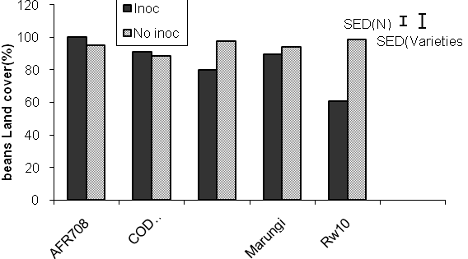
Fig. 8: bean land cover rate at Bugorhe

Soybean land cover rate at Kahembari is presented in figure 9; no figure is presented for Bugorhe site due to the fact that at this site, bean land cover was 100 % for all varieties, either on inoculated or no inoculated plants.

Land cover rate at Kahembari was lower (from 38 to 60 % on no inoculated plants and from 49 to 64 %), compared to Bugorhe and showed differences between inoculated and no inoculated varieties, except for Imperial soybean variety where there was no difference. About varieties, land cover rate of PK6 showed the lower value (39 % for no inoculated plants and 49 % for inoculated plants) whereas other recorded 60 % and more.
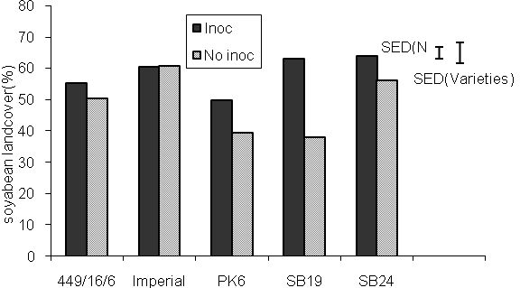
Fig. 9: soybean land cover rate at Kahembari

- Bean and soybean yield under inoculation and no inoculation
Bean yield under inoculation and no inoculation at Bugorhe in shown in figure 10 and that at Kahembari in figure 11. Figure 10 has shown that Marungi inoculated plants recorded the highest yield, followed by AFR 708 and More 8802 which did not differ significantly; the lowest yield was recorded on Rw 10. Differences between inoculated and no inoculated plants appeared on all varieties, except on CODMLB 001; inoculated plants of AFR 708 and Marungi yielded more than no inoculated plants, whereas the contrary was observed on Rw 10 and More 8802. The highest yield (2.000t/ha) was recorded on inoculated Marungi plants and no inoculated More 8802 plants. This showed in general the effect of inoculation, varying from varieties, although the soil is quoted as fertile.
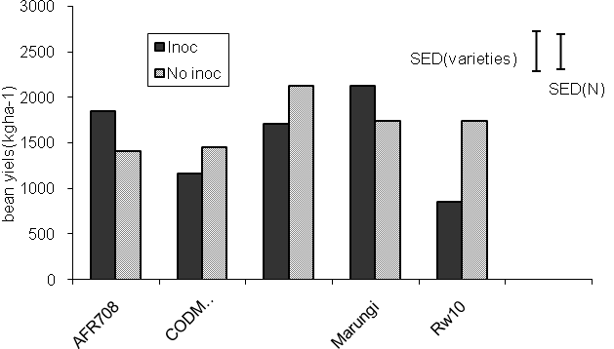
Fig. 11: Bean yield at Bugorhe
Bean yield at Kahembari, due to soil degradation was lower than that at Bugorhe; the highest value (700 kg/ha) was recorded on inoculated CODMLB001 plants and the lowest (400 kg/ha) on inoculated plants of Rw 10 and More 8802 and in no inoculated plants of CODMLB 001. Differences between inoculated and no inoculated plants appeared on all varieties, except on AFR 708; except for CODMLB 001, all no inoculated varieties recorded more yield, suggesting that other factors were limiting on this degrade soil.
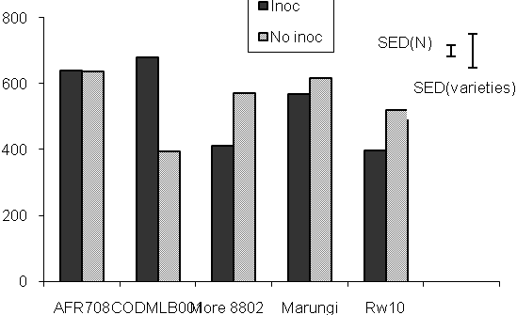
Fig. 12: Bean yield at Kahembari
Soybean yield under inoculation and no inoculation at Kahembari in shown in figure 13 and that at Bugorhe in figure 14. Soybean yield at Kahembari showed that apart from inoculated plants of 119/16/6 variety, where yield was higher than no inoculated plants, there was no difference between inoculated and no inoculated plants on other varieties. The highest yield (442 kg/ha) was recorded on no inoculated SB19 plants, and the lowest (142 kg/ha) on 449/16/6 no inoculated plants. On this degraded type of soil, inoculation showed no effect, except on 449/16/6 variety.
Soybean yield at Bugorhe was higher than that at Kahembari (2.500 kg/ha). The highest yield was recorded on SB24 plants, either on inoculated or no inoculated plants, followed by 449/16/6 inoculated plants. Soybean yield showed differences among varieties on 449/16/6, Imperial and PK 6 varieties although the soil is fertile; for other varieties, there were no differences between inoculated and no inoculated varieties. It showed also that inoculation can still show effect in fertile soil for soybean and this varies from soybean varieties. SB 24, soybean variety cropped in the Sud Kivu province for a period of time less than 5 years, can be considered as well adapted due to its high production recorded in most part of fertile soil of the province.
Due to no response of bean to inoculation, results of this experiment has given room to “need to inoculate” trials which consist of testing inoculation with commercial rhizobium strains in many areas of the mandate area of N2 Africa project.
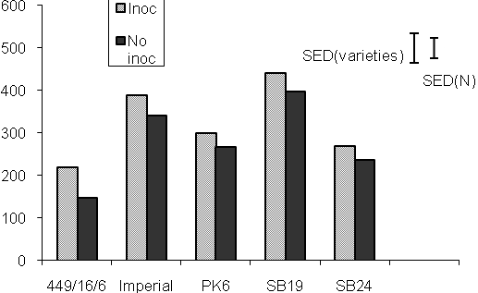
Fig. 13: soybean yield at Kahembari

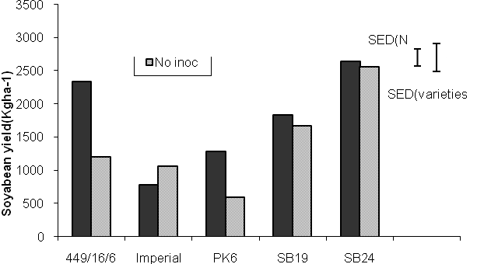
Fig. 14: soybean yield at Bugorhe
References
Giller, K.E., 2010. Putting nitrogen fixation to work for smallholder farmers in Africa. N2Africa project document. Wageningen University, the Netherlands: 67 pp.
Pypers, P, 2010. Séminaire sur la gestion intégrée de la fertilité du sol. UEA Bukavu.
Sanchez, P.A., 1997. Soil fertility replenishment in Africa: an investment in natural resource capital: 1-46. In: Buresh, R.J., Sanchez, P.A. and Calhoun, F. (Eds): Replenishing soil fertility in Africa. SSSA special publication n°51, Madison, USA.
Sanginga, N. and Woomer, P. (eds.), 2009. Integrated Soil Fertility Management in Africa: Principles, Practices and Developmental Process. Tropical Soil Biology and Fertility Institute of the International Centre for Tropical Agriculture. Nairobi: 263 pp.

