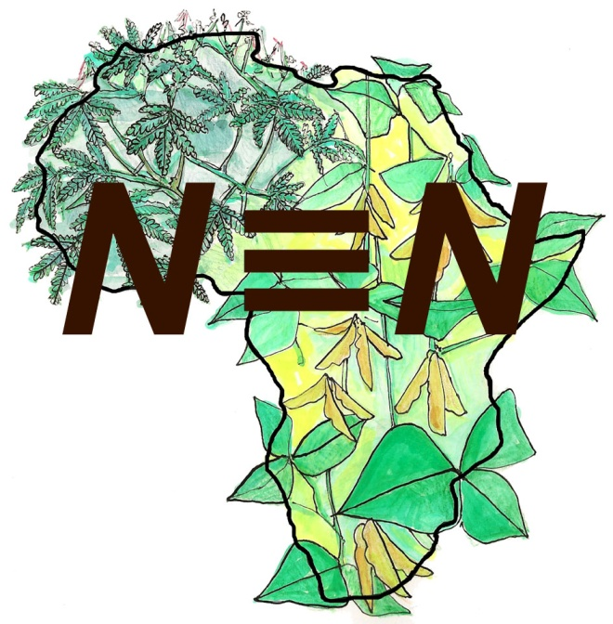

**Platforms Master Plan**

Alan Duncan

Version 1.1, 4 December 2014

[](http://creativecommons.org/licenses/by-nc/4.0/)

**N2Africa**

**Putting nitrogen fixation to work for smallholder farmers in Africa**

Summary

The first phase of N2Africa demonstrated the possibilities for increasing legume productivity through use of improved inputs but there were unanswered questions around practicable delivery mechanisms for such inputs. N2Africa now addresses these questions through a stronger emphasis on partnerships with existing input suppliers and through development of organizational innovations to enhance input supply. These include PPP’s for sustainable supply of inoculants and fertilizer, private-sector or community based legume seed system development, fostering the capacity of agro-dealers and establishment of agri-business clusters around legume marketing and value addition. The establishment of multi-stakeholder processes including platforms to facilitate such innovations is a core mechanism of the second phase of N2Africa.

The broad aim of work under the Platforms Master Plan is to engage as a project in multi-stakeholder processes including stakeholder platforms to catalyse innovation around input supply for enhanced legume productivity. This is achieved through four activity clusters:

1. Mapping existing networks - This cluster identifies existing structures upon which N2Africa can build. This is to avoid duplication and diffusion of effort.

2. Engaging in existing platforms/networks - This cluster identifies key opportunities for action to achieve N2Africa goals and objectives through collaboration in multi-stakeholder processes.

3. Committing to actions in the interests of N2Africa as part of ongoing multi-stakeholder processes - This activity involves practical steps to make progress on key actions identified in Cluster 2

4. Monitoring the outcomes of platform engagement - Learning is a key element of the platform process and a simple but systematic methodology for monitoring platform processes and the actions emerging from platform functioning is key to success. This activity will involve systematic collection of simple indicator information to track effectiveness of platform engagement.

In summary, N2Africa’s approach to multi-stakeholder platforms will be to engage in existing initiatives as a strong partner. Through this engagement the project will identify and capitalize on opportunities to use platform processes to meet N2Africa objectives and will conduct light monitoring of our engagement and the outcomes that emerge.

I. Introduction and justification

The N2Africa Master Plans are documents intended to foster a common approach across all of the N2Africa Core Countries. The plans are designed to achieve the N2Africa Vision of Success and the Research Framework of the approved project proposal. This means all Master Plans need to ensure timely delivery of the outputs and outcomes.

This Master Plan specifically addresses:

**Objective 2: Delivery and dissemination, sustainable input supply, and market access**

In particular the Master plan addresses

**Objective 2.1: Constitute and facilitate in-country/in-region N2Africa stakeholder platforms**

But through the activities of the platforms contributions to various other objectives will emerge, especially:

**2.3. Create widespread awareness on N2Africa technologies and interventions**

**2.5. Facilitate private-public partnerships towards the sustainable supply of inoculants and fertilizer**

**2.6. Facilitate the establishment of private sector-led and/or community-based legume seed systems**

**2.7. Engage agro-dealer and other last-mile delivery networks in supplying legume agro-inputs**

**2.8. Establish agri-business clusters around legume marketing and value addition**

II. Underlying principles

N2Africa in Phase I had a strong focus on increasing productivity through agronomic trials to understand the key factors in the (GL × GR) × E × M interaction that determine productivity and yield (the phenotype). As we move into Phase II, this emphasis continues but there is additional emphasis on market and value chain issues. Phase 1 demonstrated the possibilities for increasing legume productivity through use of improved inputs but there were unanswered questions as to practicable delivery mechanisms for such inputs. Phase II addresses these questions through a stronger emphasis on partnerships with existing input suppliers and through development of organizational innovations to enhance input supply. These include PPP’s for sustainable supply of inoculants and fertilizer, private-sector or community based legume seed system development, fostering the capacity of agro-dealers and establishment of agri-business clusters around legume marketing and value addition. The establishment of multi-stakeholder processes including platforms to facilitate such innovations is a core mechanism of N2Africa Phase II.

**Aim**

**•** To engage as a project in multi-stakeholder processes including stakeholder platforms to catalyse innovation around input supply for enhanced legume productivity.

**Approach**

• Map existing networks

• Engage in existing platforms/networks

• Commit to actions in the interests of N2Africa as part of on-going multi-stakeholder processes

• Monitoring of outcomes of platform engagement

III. Activity clusters within the Platform Master Plan and relation to other Master Plans

• The Platform Master Plan consists of four interlinked activity clusters as outlined in the Approach section above: Map existing networks, Engage in existing platforms/networks, Commit to actions, Monitoring of outcomes.

1. Map existing networks

o Existing multi-stakeholder forums will be mapped to assess their suitability for N2Africa purposes. Where existing platforms exist, N2Africa will prefer to engage in existing initiatives rather than setting up parallel structures

2. Engage in existing platforms/networks

o Participate regularly in existing platforms networks at a range of scales: national, regional, local

o Identify key opportunities to influence actions emerging from existing platforms to the benefit of N2Africa goal and objectives

3. Commit to actions

o Lead some actions that are directly beneficial to N2Africa e.g. organization of input supply mechanisms

o Design and implement actions via rolling action plan

o Follow up of action plan to ensure progress

4. Monitoring

o Develop simple M&E systems to track any beneficial actions emerging from N2Africa engagement in existing platforms

o Regularly complete M&E templates

The Platform Master Plan interacts logically with the other Master Plans. This is because Stakeholder Platforms will form a useful forum for integrating work across the programme. As well as acting as action platforms to stimulate organizational innovation, Stakeholder Platforms will provide the space for key stakeholders to learn about what is going on across the project and to adjust activities to ensure integration across key project components: agronomy, gender, nutrition, Rhizobiology, dissemination and communication. As such the Stakeholder Platforms will play a dual role: action platforms and knowledge platforms.

Engagement with other key stakeholders through Stakeholder Platforms could be seen as duplicating the public-private partnership approach outlined in the Dissemination Masterplan. However, Stakeholder Platforms and Public-Private Partnerships differ in important respects and represent complementary approaches. Stakeholder Platforms have useful functions in embedding N2Africa within the wider national efforts around legume intensification in each of the N2Africa countries. They can serve to form connections between N2Africa and other key players and sustain key stakeholder relationships. They can be useful in identifying key value chain constraints and opportunities along with the various key actors who could then collaborate to deal with the constraints and capitalize on the opportunities. Stakeholder Platforms are also potentially useful in dealing with constraints at policy level which are not necessarily tractable through PPP’s. Public-Private Partnerships adopt a more focused approach to dealing with a previously identified value chain constraint from the outset. They are a mechanism for bringing mutual accountability to actors within a well-defined network in order to achieve some common aims. The use of PPP’s will be useful where private sector actors have already been identified and relationships built. They are often more attractive for private players for whom extended time spent in Stakeholder Platform meetings is unrealistic.

IV. Interactions between activity clusters

The platform process is iterative and based on a learning cycle. In particularly there is an action research learning cycle among the final two activity clusters: (3) Commit to actions and (4) Monitoring. As actions emerge from the Platform Facilitation cluster, the key issues will change requiring further reflection and analysis leading to design of new actions. The success of these actions will be assessed through the Monitoring Cluster. A generic learning cycle based on experience across a range of innovation platform projects is presented in the Figure below. In this scheme the platform initially decides on focus, and then identifies options (3). These options are then tested and refined (4) before being analysed (7). This analysis and learning leads to a refinement of the focus (2) and so the learning cycle continues.

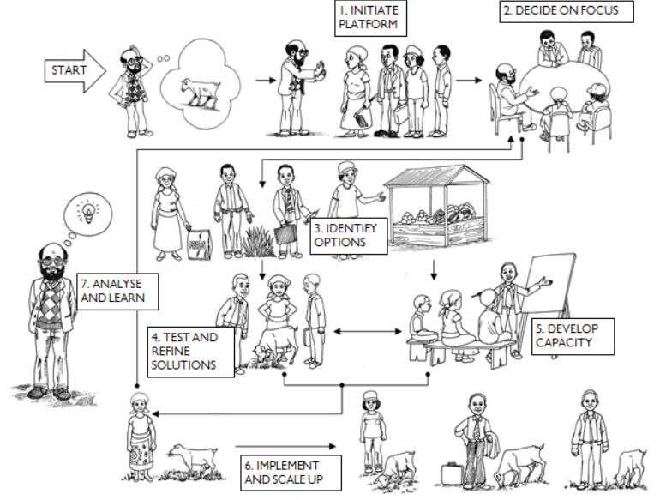

V. Cluster contents

V.1. Mapping existing networks

This cluster aims to determine existing structures upon which N2Africa can build. This is to avoid duplication and diffusion of effort.

**Task 2.1.1** Conduct key informant interviews to gather information on existing multi-stakeholder networks focusing on legumes at various scales (Year 1)

This task generates understanding on what existing networks exist and will develop recommendations on which existing platforms N2Africa should engage with at various scales: national, regional, local; and around various commodities.

V.2. Engage in existing platforms/networks

This cluster identifies key opportunities for achieving N2Africa goals and objectives through collaboration in existing multi-stakeholder processes.

**Task 2.1.2** Participate in identified platforms: national, regional, site.

This is a systematic effort to engage in existing platforms in order to embed N2Africa in wider initiatives around legume intensification. This will involve systematic documentation of attendance at meetings and key actions agreed at meetings.

**Task 2.1.3** Identify key opportunities to influence actions emerging from existing platforms to the benefit of N2Africa goal and objectives

This task will involve reflecting on dialogue within existing platforms and identifying opportunities to work collaboratively with platform members on actions which further the goals and objectives of N2Africa. This will involve looking for matches between the geographical and technical focus of any actions emerging from platforms and prioritizing those that N2Africa should be involved with.

For guidance on nested platforms see Innovation Platform Brief 9: Linking action at different levels through innovation platforms

V.3. Commit to actions

**Task 2.1.4** Lead or participate in some actions that are directly beneficial to N2Africa e.g. organization of input supply mechanisms

This activity will involve some practical steps to make progress on some key actions identified in Cluster V.2. Some proactive engagement in on-going actions will be needed and potentially some initiation of new actions that are in line with N2Africa objectives. For example, actions could include collaboration with private sector inoculant suppliers to arrange delivery mechanisms for inoculants to N2Africa target farmers. Or actions could involve setting up collective action for more efficient marketing of legume outputs. Or action could also involve collaborating with other projects/programs platforms promoting legume intensification locally or regionally.

V.4. Monitoring

**Task 2.1.5** Design and implement simple monitoring system for documenting beneficial outcomes from platform engagement

Learning is a key element of the platform process and a simple but systematic methodology for monitoring platform processes and the actions emerging from platform functioning is key to success. The M&E activity also helps in identifying and documenting research and development outcomes emerging from platform functioning. M&E is one of the more challenging aspects of running Stakeholder Platforms and requires discipline and realism to make it work. There are a number of options in approaching the M&E of platforms. A common pitfall is to design complex methods which tend to fall by the wayside early on. Some basic principles can help to avoid this:

- At the very least, high quality summary notes should be taken for each meeting and either shared with platform members or even better posted online

- These notes should document proposed actions and update progress on rolling basis.

- Platform members themselves should be closely involved in M&E

- Some simple indicators of success should be developed and then monitored systematically. These might include: Number of business arrangements emerging from platforms? Sale volumes? Number of sector issues addressed? Voluntary growth of membership?

Guidance on monitoring platform processes can be found in Innovation Platform Brief 5: Monitoring Innovation Platforms

VI. Approximate timing of cluster implementation

In broad terms Activity Clusters 1 and 2 should be largely complete in Year 1. Activity Clusters 3 and 4 are on-going activities but progress should be reviewed on each at the end of each project year.

VII. Further reading

Innovation Platform Practice Briefs – GIVE URL

Boogaard, B.K., Schut, M., Klerkx, L., Leeuwis, C., Duncan, A., Cullen, B. (2013). Critical issues for reflection when designing and implementing Research for Development in Innovation platforms. Report for the CGIAR Research Program on Integrated Systems for the Humid Tropics. Knowledge, Technology & Innovation Group (KTI), Wageningen University & Research centre, the Netherlands.

https://cgspace.cgiar.org/bitstream/handle/10568/35028/R4D_InnovationPlatforms.pdf?sequence=1